Whareama School
www.whareama.school.nz
Newsletter No. 8
26th March, 2018
Term 1, Week 9

CURRICULUM
This term we have managed to have a wide variety of opportunities happen inside and outside of the classroom and we are at a point of where we need to look at our curriculum, assessments and procedures in learning across the school. We will be setting a date for a community consultation meeting where we want to have as many families represented as possible to discuss the strategic direction of our school. Start to think now about how you perceive your child leaving Whareama School as a Year 8 student including what skills, values and attributes you aspire for them. We will be discussing with you what some of the values mean, the new curriculum, government directions and possible changes to how our school operates. Once we have our meeting it will be followed up by a community survey for us to gather information, which will ensure we have a clear focus and direction moving forward. Please book in your diaries Thursday the 3rd of May, 5pm at school. The meeting should take no more than 1 hour and we promise you a warm drink and some snacks. The meeting is for adults as we will be surveying our students through a separate survey. The library will be open with a video playing for kids who need to be entertained at school.

KIDZ CONFERENCE
Good luck to all the kids whose parents have registered them for the Kidz Conference this Wednesday at the Copthorne Hotel. It will be interesting to hear all the feedback from this event as they have a very big day planned. Every child has a school polo shirt and will be given a tracksuit on Tuesday so it is expected they will wear these to the event. Please return the tracksuits to school on Thursday.
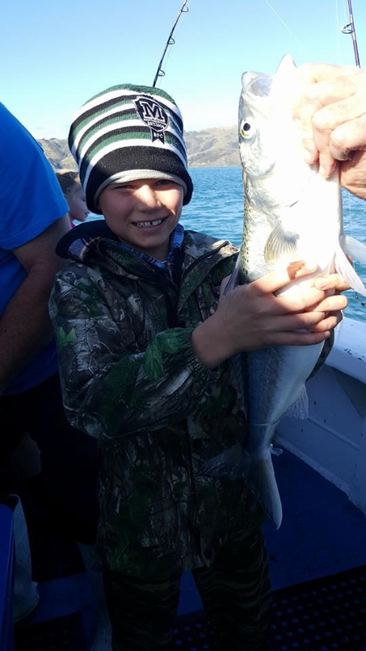
TAKE A KID FISHING DAY
Poppy, Logan, Harrison and Rane will be going on the Pukemanu Fishing Clubs Take a Kid Fishing Day on Wednesday. They will be on a charter boat out of the Mana Marina with 6 other rural schools and they are really excited about their day that they have planned. Thanks to the club for this opportunity.

LITERMANIA
Zarlia, Charlee, Rane and Poppy will be representing our school at the MIS Litermania competition this Thursday. Good luck to the girls and you will all get your tracksuits to wear on Tuesday and then need to return them to school the following week, after the Easter break. Thanks Sarah for sorting out the transport for this.

LUNCH ORDERS – WEEK 10
Please send in your order forms for next week’s lunches by Thursday the 5th of April.

SPORTS
Tennis: The Whareama Smashers played against MIS Deuces on Friday night in the competition finals game. They ended up winning 6 matches to nil so they will end up being promoted to the Advanced A grade in Term 4. Well done to this team who have only got better and better each week.

LEARNING AMBASSADORS
Mathew and Kaitlyn will be our Learning Ambassadors for 2018. They will be attending a meeting each term with students from all the other Masterton Schools to help work on our Masterton Schools’ Learner Qualities. Their first meeting in Monday the 9th of April at REAP house.

WORKING BEE
Eddie and I have planned a working bee for school on Sunday the 29th of April at 10am at school. We welcome John and Rachel O’Neale as our new grounds people and there are a few minor jobs we want to do to tidy up around the school. Please be at school at 10am and we will have a list of jobs on the staffroom door. We aim for this to take a couple of hours and then we will have a sausage sizzle and drink for lunch. Of course kids are welcome but they will need to be help out in jobs with their adults they come with.
Upcoming Events:
TERM 1:
Tues 28th March Kidz Conference
Weds 28th March Take a Kid Fishing Day – Logan/ Harrison/ Rane/ Poppy
Thurs 29th March Litermania – Poppy/ Rane/ Zarlia/ Charlee
FRI 30th – TUES 3rd APRIL – EASTER HOLIDAY BREAK
Mon 9th April Learning Ambassadors – Kaitlyn/ Mathew
Fri 13th April Term 1 Ends
SUNDAY 29TH APRIL SCHOOL WORKING BEE – 10am
Mon 30th April Term 2 Starts
Thurs 3rd May SCHOOL COMMUNITY MEETING – 5pm

Regards
Darren, Heather, Sandy and Diana

